# 

**Introduction** **1**

Key Phases: 1

Cycle Frequency and Submission Process: 2

Final Remarks and Accessibility: 2

**Manager Review Cycle** **2**

Self Review 2

Review to Reportees 4

Review to Manager 6

Review Request 8

**Employee Review Cycle** **12**

Self Review 12

Review To Manager 14

**Second Draft** **16**

**Introduction** **16**

Key Phases: 16

Cycle Frequency and Submission Process: 17

Final Remarks and Accessibility: 17

**Performance Evaluations** **17**

Self Review 17

Review of Reportees 19

Review of Manager 21

Review Request 23

# 

# Introduction

The X-Pulse 360 Review process enables Xgrid a comprehensive quarterly evaluation framework for employees, fostering continuous improvement and feedback.

### Key Phases:

* **Active Phase**: Initiates the quarterly review cycle. During this phase, employees conduct self-assessments, managers review their team members, and peer-to-peer evaluation (future implementation) takes place. Reviews can be saved as drafts but cannot be edited post-submission.
* **Processing Phase**: Marks the ongoing evaluation stage.
* **Done Phase:** Concludes the review cycle, freezing the review form. Final remarks can be edited until this phase.

### Cycle Frequency and Submission Process:

* Quarterly reviews occur four times a year, aligning with Xgrid’s organizational objectives.
* Reviews are submitted only once for each quarter and require manager approval before completion.
* Drafts can be saved before submission but become inaccessible after the Active phase deadline.

### Final Remarks and Accessibility:

* The Final Remarks section is editable by the manager before the Done phase.
* The Final Remarks section can be edited any time if the review process isn’t in the Done phase. Any user can only see his Final Remarks for a review once that review has been moved to the Done phase.

# Manager Review Cycle

The X-pulse 360 review process imposes five responsibilities on every manager of the company:

1. Self Review
2. Review to Reportees
3. Review to Manager
4. Review Request
5. Final Review to Reportees

## Self Review

As part of the self review process, you are required to review yourself following the steps below:

1. Log in to your X-Pulse account
2. Click on **Reviews** button from left pane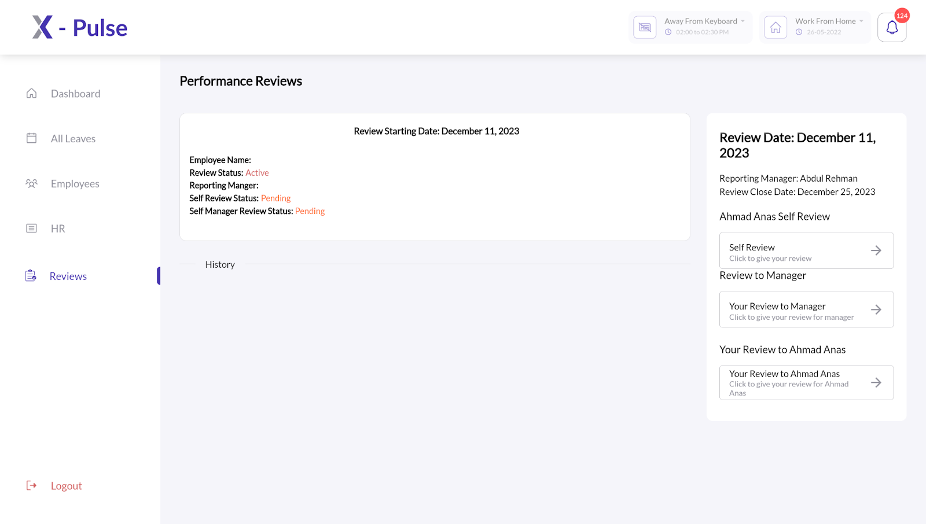
3. Click on the **Performance Review** available for the current quarter.  
   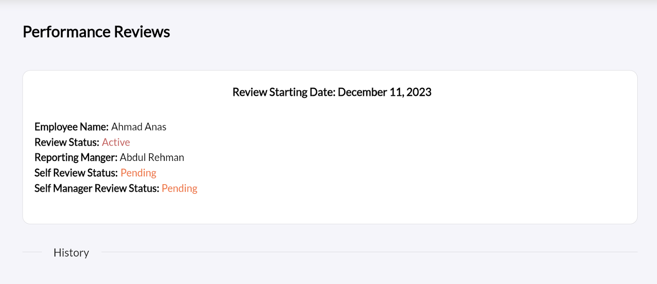
4. Click on **Self-Review** from the right pane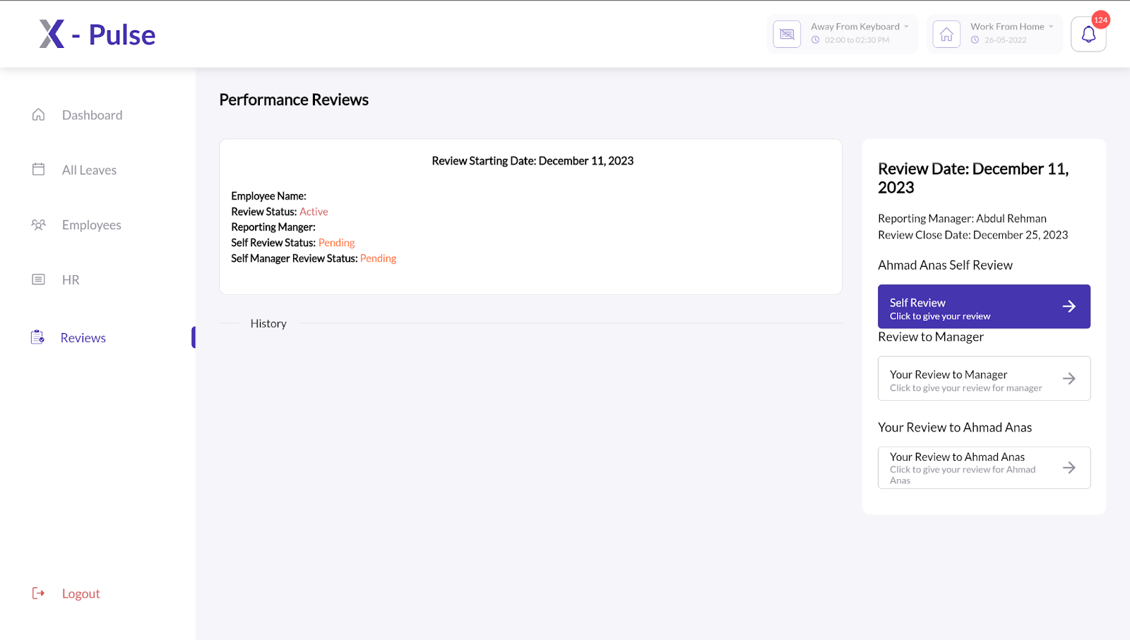
5. Review yourself based on the following parameters:
   1. Work Quality
   2. Complexity & Ambiguity
   3. Predictability of Delivery
   4. Team Play
   5. Comments (Optional)

Note: The fields marked **\*** are necessary to fill. Once you’ve filled in the form, you can either save it as draft for later amendments or submit the form to move it to the Processing phase.

## Review to Reportees

Each manager of the company is required to review his/her team members by following the steps below:

1. Log in to your X-Pulse account
2. Click on **Reviews** button from left pane
3. Click on the **Performance Review** available for the current quarter.  
   
4. In the right pane, you’ll find a naming list of all your team members. Click on each of your team members to begin the review process.  
   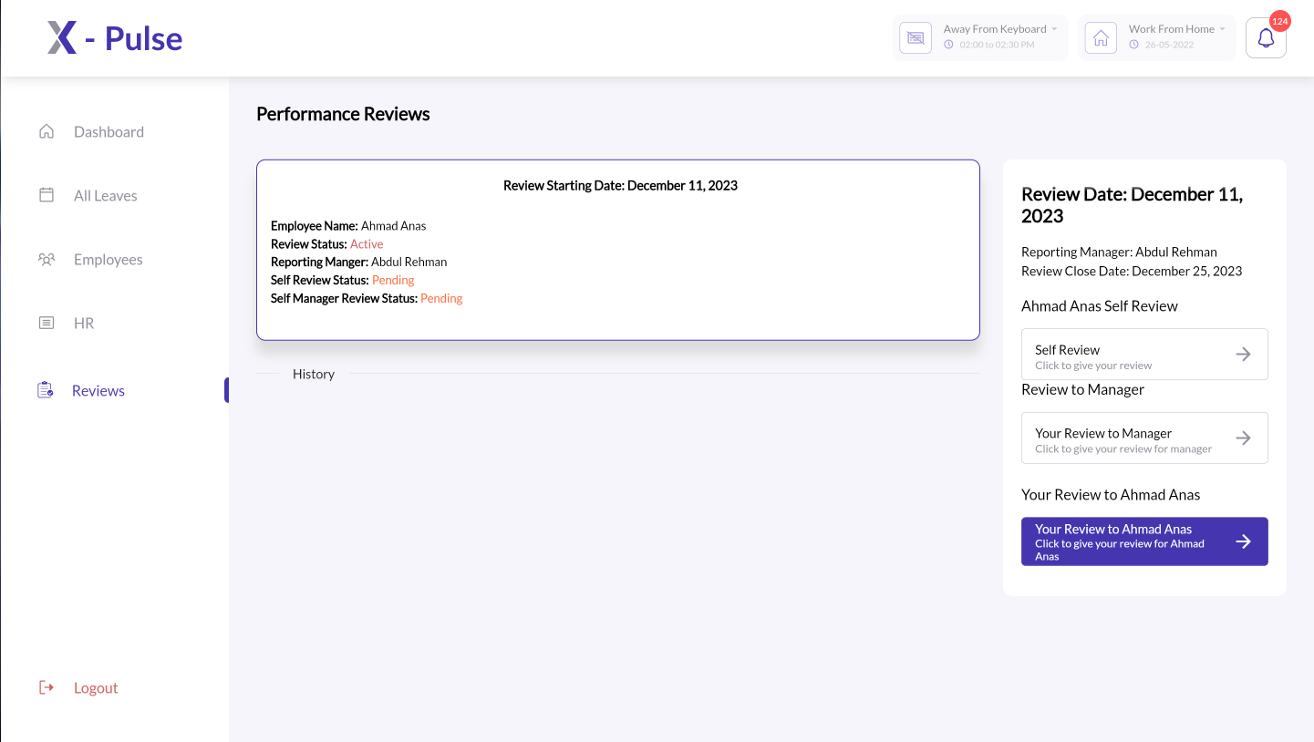
5. Review each member based on the following parameters:
   1. Work Quality
   2. Complexity & Ambiguity
   3. Predictability of Delivery
   4. Team Play
   5. Comments (Optional)

The fields marked **\*** are necessary to fill. Once you’ve filled in the form, you can either save it as draft for later amendments or submit the form to move it to the Processing phase.

## Review to Manager

As part of Review to Manager process, you are required to review your reporting manager following the steps below:

1. Log in to your X-Pulse account
2. Click on **Review** button from left pane  
   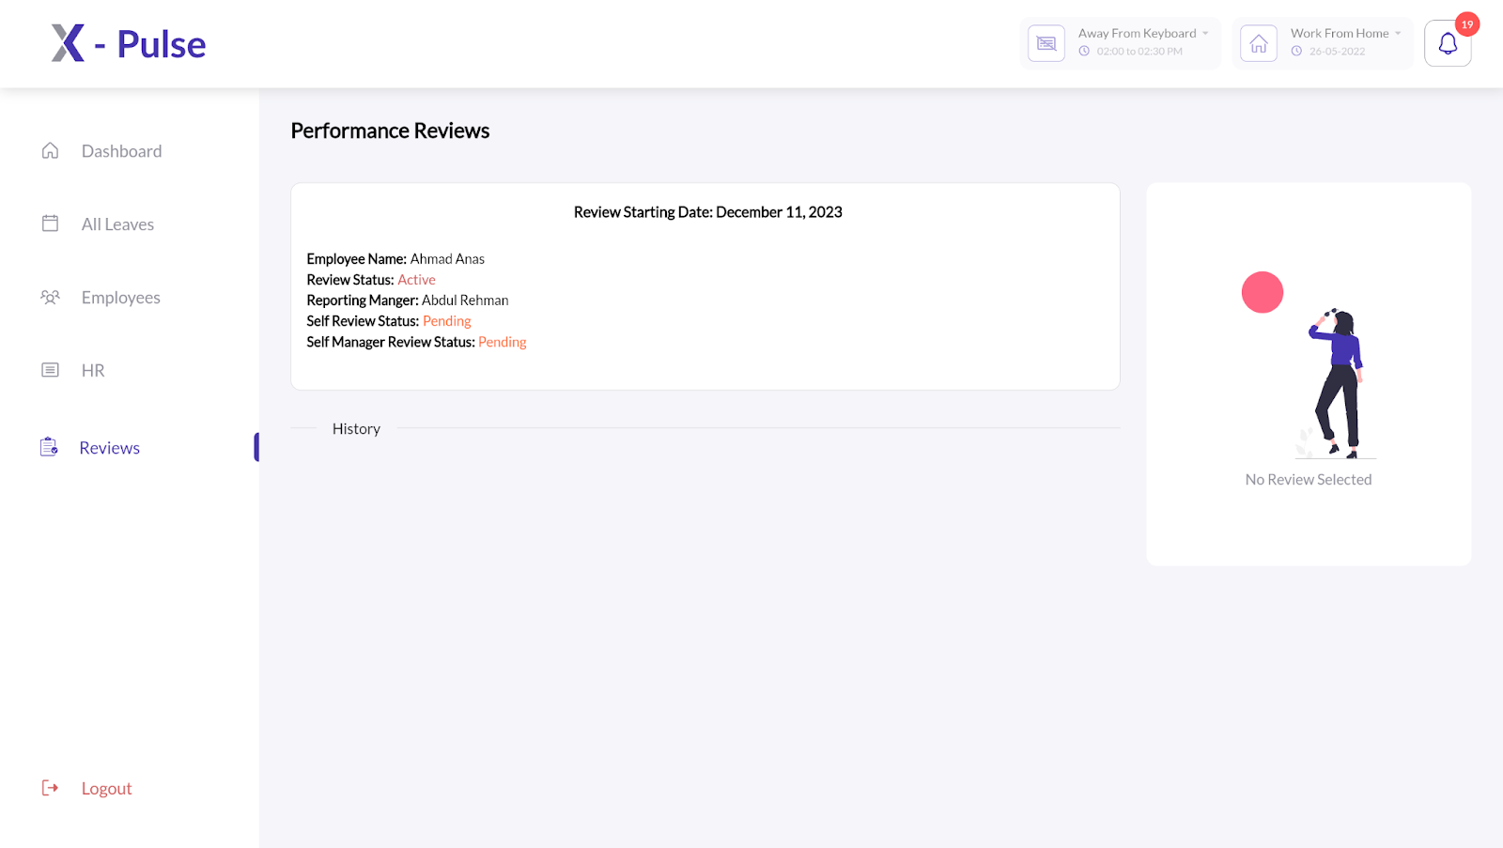
3. Click on the **Performance Review** available for the current quarter.  
   
4. Click on **Your Review to Manager** from the right pane  
   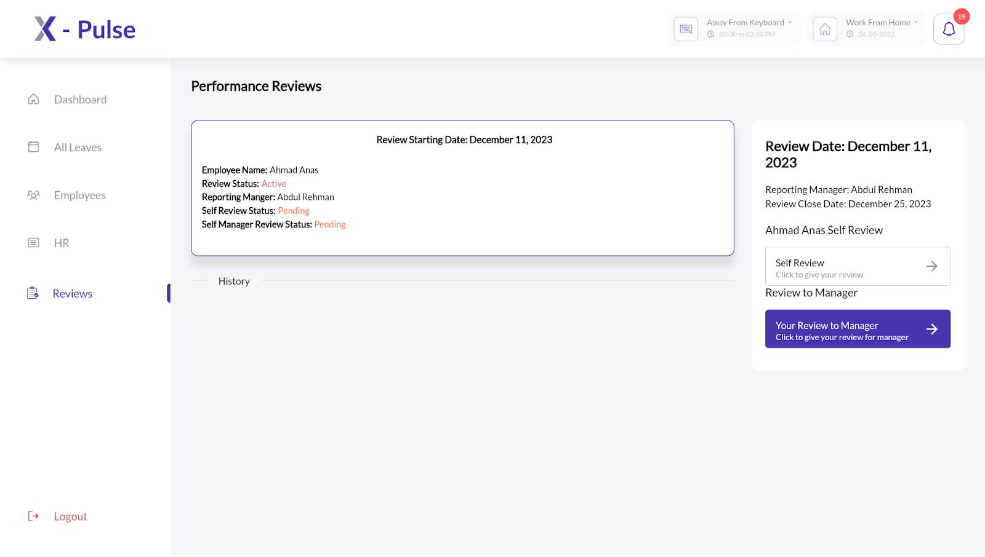
5. Review your reporting manager based on the following parameters:
   1. Work Quality
   2. Complexity & Ambiguity
   3. Predictability of Delivery
   4. Team Play
   5. Comments (Optional)

**Note**: The fields marked **\*** are necessary to fill. Once you’ve filled in the form, you can either save it as draft for later amendments or submit the form to move it to the Processing phase.

The review to manager process is completed once a review is Submitted by the employee for further processing by the respective manager.

## Review Request

The Review Request feature enables the managers to request a review for one or more of their team members who are still a part of their team however their quarterly job requirements compel them to work under different managers. To request a review of your team member from the relevant team manager, follow the steps below:

1. Log in to your X-Pulse account
2. Click on **Reviews** button from left pane.  
   
3. Click on the **Performance Review** available for the current quarter.  
   
4. From the left pane, select the team member whose review you need to request from a different manager and select the relevant review quarter.  
   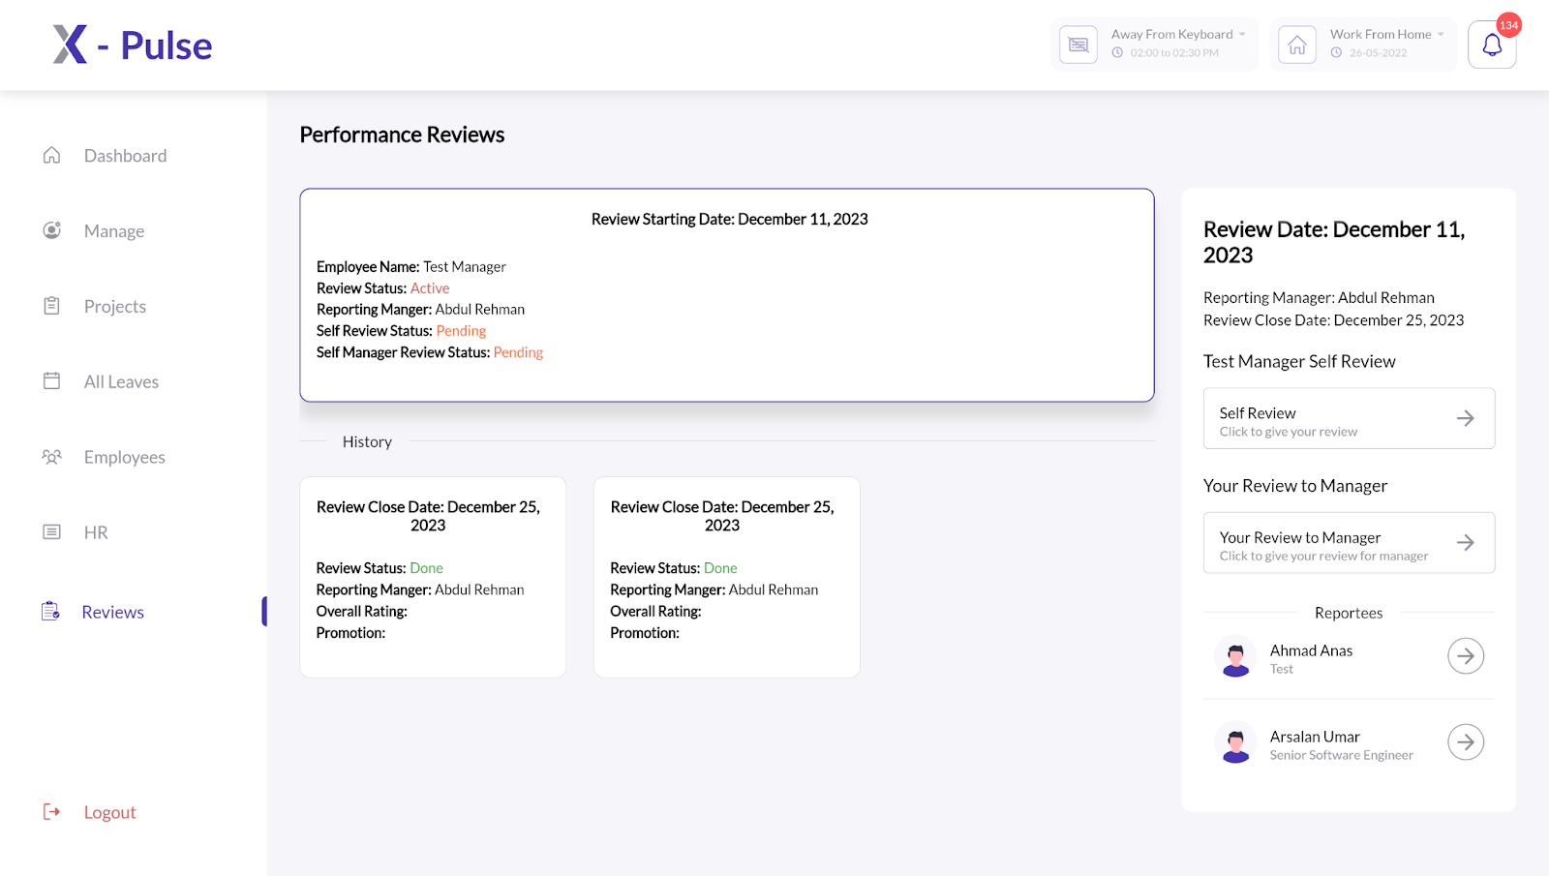
5. Click on **Your Review to <name>.**   
   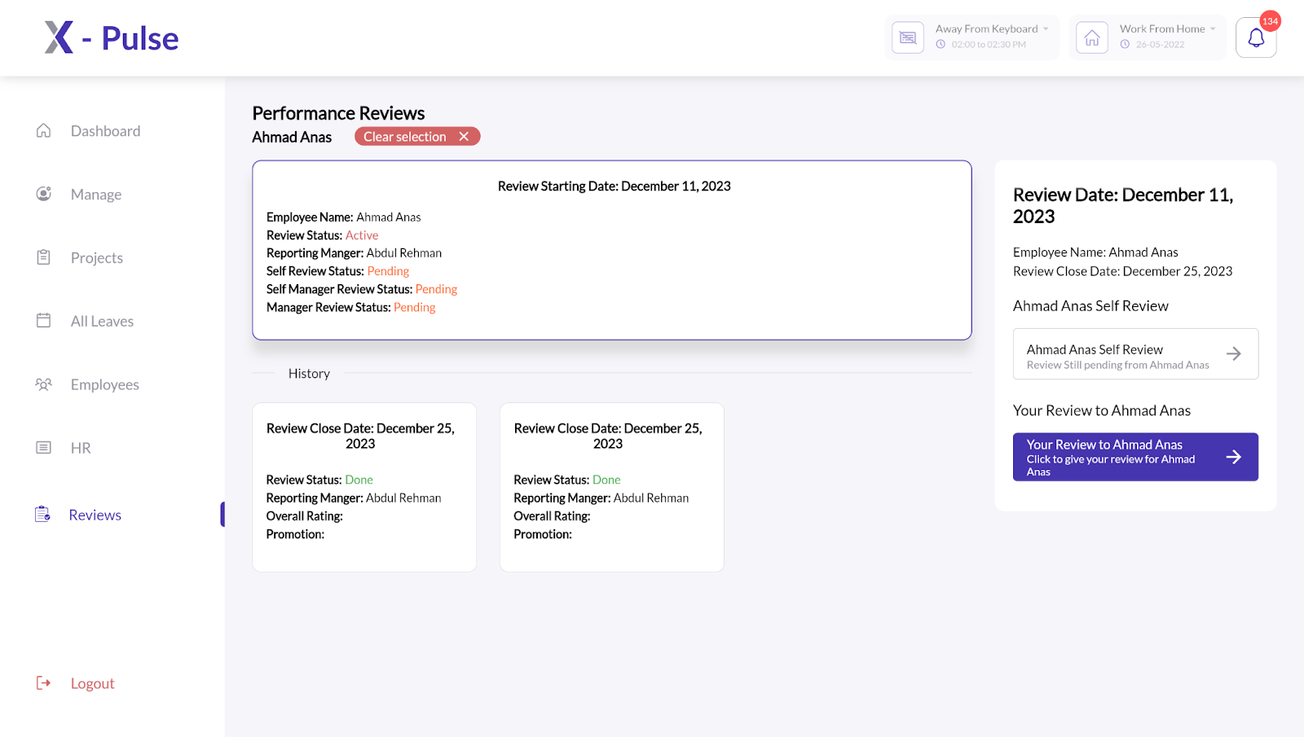
6. Navigate to **Redirect Review** from the top right corner  
   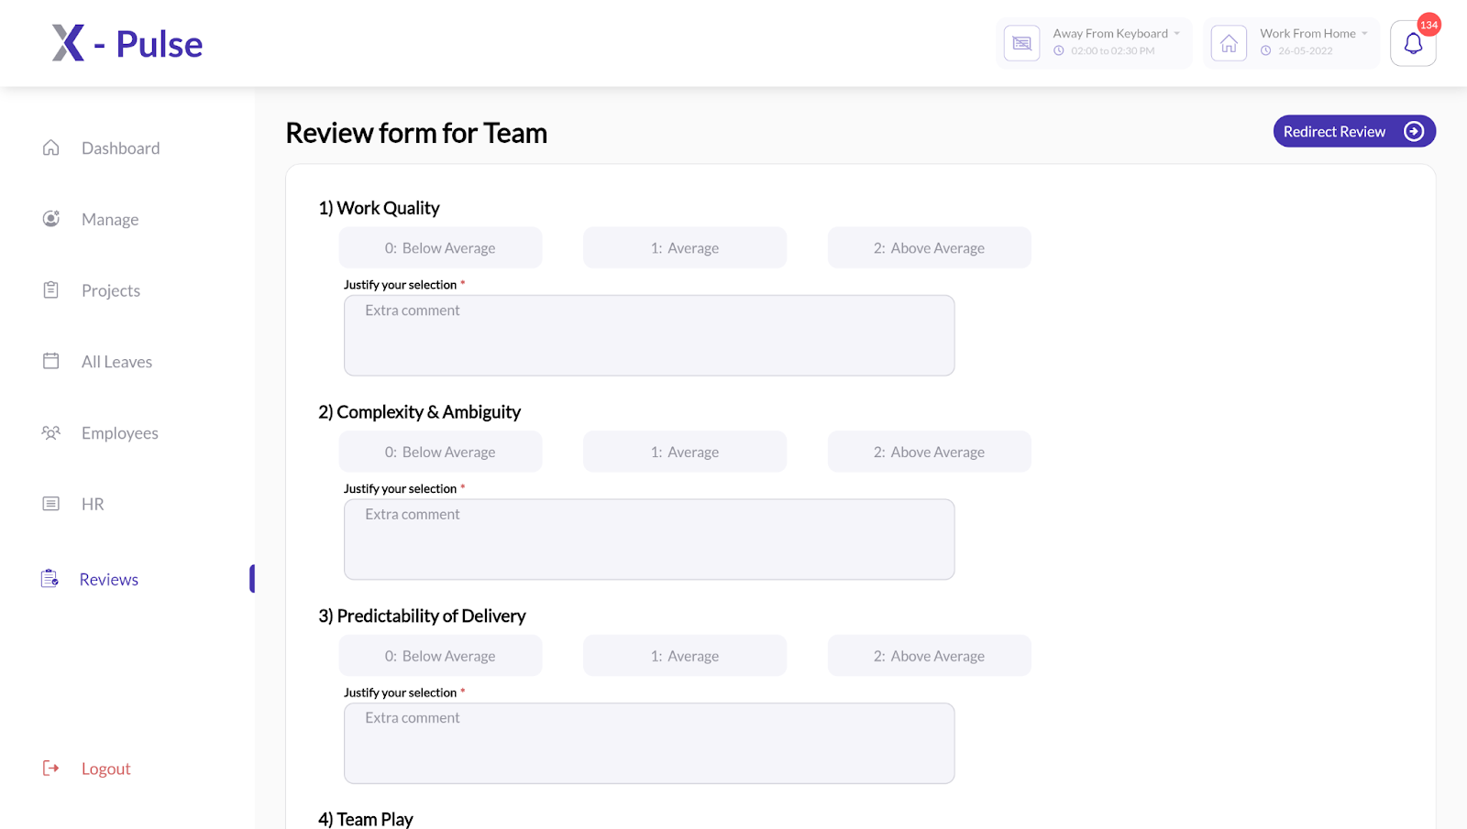
7. Select an Employee that you’d like to request review from.  
   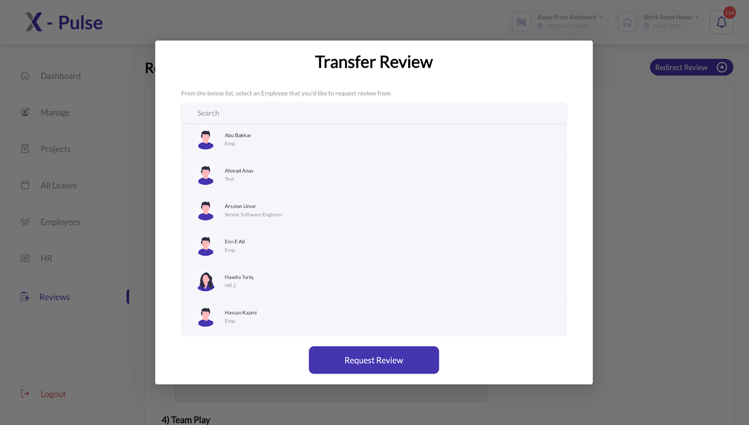

Once you have requested a review of one or more of your team members, you can check its status by navigating to your team member(s) profile from the right pane.

# 

# Employee Review Cycle

The X-pulse 360 review process imposes five responsibilities on each employee of the company:

1. Self Review
2. Review to Manager
3. Review Request

## Self Review

As part of the self review process, you are required to review yourself following the steps below:

1. Log in to your X-Pulse account
2. Click on **Reviews** button from left pane  
   
3. Click on the **Performance Review** available for the current quarter.  
   
4. Click on **Self-Review** from the right pane  
   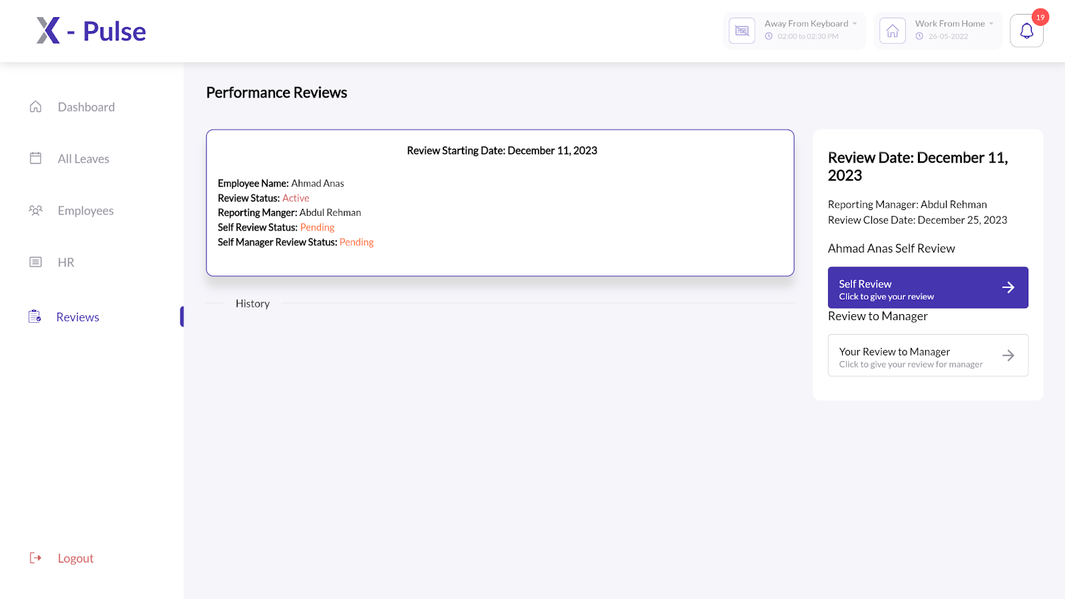
5. Review yourself based on the following parameters:
   1. Work Quality
   2. Complexity & Ambiguity
   3. Predictability of Delivery
   4. Team Play
   5. Comments (Optional)

Note: The fields marked **\*** are necessary to fill. Once you’ve filled in the form, you can either save it as draft for later amendments or submit the form to move it to the Processing phase.

The Self Review process is completed once a review is Submitted by the employee for further processing by the respective manager.

## Review To Manager

As part of Review to Manager process, you are required to review your reporting manager following the steps below:

1. Log in to your X-Pulse account
2. Click on **Review** button from left pane  
   
3. Click on the **Performance Review** available for the current quarter.  
   
4. Click on **Your Review to Manager** from the right pane  
   
5. Review your reporting manager based on the following parameters:
   1. Work Quality
   2. Complexity & Ambiguity
   3. Predictability of Delivery
   4. Team Play
   5. Comments (Optional)

Note: The fields marked **\*** are necessary to fill. Once you’ve filled in the form, you can either save it as draft for later amendments or submit the form to move it to the Processing phase.

The Review to Manager process is completed once a review is Submitted by the employee for further processing.

4 Performance Evaluations

1. Self Review
2. Review of Reportee (add a note)
3. Review of Manager
4. Peer Review (just mention it is under process)

Additional Feature: Review Request

—---------------------------------

# Second Draft

# Introduction

The X-Pulse 360 Review process enables Xgrid a comprehensive quarterly evaluation framework for employees, fostering continuous improvement and feedback.

### Key Phases:

* **Active Phase**: Initiates the quarterly review cycle. During this phase, employees conduct self-assessments, managers review their team members, and peer-to-peer evaluation (future implementation) takes place. Reviews can be saved as drafts but cannot be edited post-submission.
* **Processing Phase**: Marks the ongoing evaluation stage.
* **Done Phase:** Concludes the review cycle, freezing the review form. Final remarks can be edited until this phase.

### Cycle Frequency and Submission Process:

* Quarterly reviews occur four times a year, aligning with Xgrid’s organizational objectives.
* Reviews are submitted only once for each quarter and require manager approval before completion.
* Drafts can be saved before submission but become inaccessible after the Active phase deadline.

### Final Remarks and Accessibility:

* The Final Remarks section is editable by the manager before the Done phase.
* The Final Remarks section can be edited any time if the review process isn’t in the Done phase. Any user can only see his Final Remarks for a review once that review has been moved to the Done phase.

# Performance Evaluations

The X-pulse 360 performance evaluations process offers five different functionalities to its employees, function to their incumbent role:

1. Self Review
2. Review of Reportees
3. Review of Manager
4. Review Request
5. Peer Review (not functional yet)

## Self Review

As part of the self review process, you are required to review yourself following the steps below:

1. Log in to your X-Pulse account
2. Click on **Reviews** button from left pane
3. Click on the **Performance Review** available for the current quarter.  
   
4. Click on **Self-Review** from the right pane
5. Review yourself based on the following parameters:
   1. Work Quality
   2. Complexity & Ambiguity
   3. Predictability of Delivery
   4. Team Play
   5. Comments (Optional)

**Note**: The fields marked **\*** are necessary to fill. Once you’ve filled in the form, you can either save it as draft for later amendments or submit the form to move it to the Processing phase.

## Review of Reportees

This functionality is available only at the managerial level. Each manager of the company is required to review his/her team members by following the steps below:

1. Log in to your X-Pulse account
2. Click on **Reviews** button from left pane
3. Click on the **Performance Review** available for the current quarter.  
   
4. In the right pane, you’ll find a naming list of all your team members. Click on each of your team members to begin the review process.  
   
5. Review each member based on the following parameters:
   1. Work Quality
   2. Complexity & Ambiguity
   3. Predictability of Delivery
   4. Team Play
   5. Comments (Optional)

**Note:** The fields marked **\*** are necessary to fill. Once you’ve filled in the form, you can either save it as draft for later amendments or submit the form to move it to the Processing phase.

## Review of Manager

As part of Review of Manager process, you are required to review your reporting manager following the steps below:

1. Log in to your X-Pulse account
2. Click on **Review** button from left pane  
   
3. Click on the **Performance Review** available for the current quarter.  
   
4. Click on **Your Review to Manager** from the right pane  
   
5. Review your reporting manager based on the following parameters:
   1. Work Quality
   2. Complexity & Ambiguity
   3. Predictability of Delivery
   4. Team Play
   5. Comments (Optional)

**Note**: The fields marked **\*** are necessary to fill. Once you’ve filled in the form, you can either save it as draft for later amendments or submit the form to move it to the Processing phase.

## Review Request

This functionality is available only at the managerial level.The Review Request feature enables the managers to request a review for one or more of their team members who are still a part of their team however their quarterly job requirements compel them to work under different managers. To request a review of your team member from the relevant team manager, follow the steps below:

1. Log in to your X-Pulse account
2. Click on the **Reviews** button from the left pane.  
   
3. Click on the **Performance Review** available for the current quarter.  
   
4. From the left pane, select the team member whose review you need to request from a different manager and select the relevant review quarter.  
   
5. Click on **Your Review to <name>.**   
   
6. Navigate to **Redirect Review** from the top right corner  
   
7. Select an Employee that you’d like to request review from.  
   

Once you have requested a review of one or more of your team members, you can check its status by navigating to your team member(s) profile from the right pane.